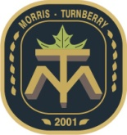MUNICIPALITY OF MORRIS-TURNBERRY

2025 SPRING YARD WASTE COLLECTION

The Municipality will be picking up leaves, grass clippings and yard waste in the   
Morris-Turnberry **URBAN** areas on the following dates**:**

***[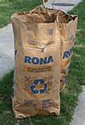](http://search.live.com/images/results.aspx?q=pictures+of+yard+waste&form=IIRE2#focal=78a5e8a2e620f89456c2e438a328d3dc&furl=http://farm4.static.flickr.com/3011/2440245933_00067ec093.jpg)***

***[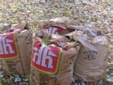](http://search.live.com/images/results.aspx?q=pictures+of+yard+waste&form=IIRE2#focal=03747f1deccd88366700598991ef5abe&furl=http://www.orangeville.org/cms/pages/images/yard_waste.jpg)*Tuesday April 22nd, 2025, and**

**Tuesday May 20th, 2025**

**Areas included:** Belgrave, Belmore, Bluevale, Fringe of Brussels, Junctionville, Lower Wingham, North Wingham, Turnberry Estates, Walton

Leaves, grass clippings and yard waste may also be delivered to the Morris-Turnberry Landfill Site at 85047 Clyde Line, any Wednesday or Saturday.

Materials MUST be placed at the curb in Biodegradable Bags.

**Paper Organic Yard Waste bags** can be purchased at Stainton’s Home Hardware, Hodgins Building Centre in Wingham, Midwest Co-operative in Belgrave, McDonald Home Hardware in Brussels, and Watson’s Home Hardware in Blyth or at a retailer of your choice.

**The bags must be placed at the curb by 7 a.m. for collection.**The Bags will be picked up by a different truck than the regular garbage.

**Plastic bags are not acceptable for yard waste and will NOT be picked up.**

The Municipality encourages grass clippings to be left on your lawn providing valuable moisture and nutrients to your lawn.

Residents should not include tree branches, which are greater than 4” in diameter and 5 feet long. Use strong twine to bundle tree or shrub branches.

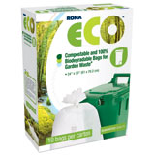**Yard waste DOES NOT include sod, soil, lumber, tree stumps or stones   
and must be free of metal, food wastes and garbage.   
The Municipality will NOT pick up loose branches!**

Any questions please contact the Municipal office at 519-887-6137